React JS Training

Day 1

07/08/2023

ES6 features

* let vs var vs const
* Default function parameters
* Rest parameter
* Spread operator
* For-of
* Template Literals
* Destructuring
* Modules
* Class
* Arrow Functions

<https://www.google.com---------->> URL

req(http/https)------------------------------🡪

Client Server

🡨-----------Res(http/https)

Html/HTML5

CSS/CSS3

JavaScript

Java (spring boot)

Asp.net

Php

Python

Node Js

JavaScript : JavaScript was object based interpreter scripting language. Do to validation on client side or browser side.

Node JS : Before Node js JavaScript known as client side scripting language

But after node js JavaScript also known as client side as well as server side scripting language.

Old version of JavaScript support only objects not class concept till ES5

ECMA (European Computer Manufacture Association) ECMA is a concept.

One of the implementation of ECMA is JavaScript.

But from ES6 onward JavaScript also known as object oriented scripting language.

To declare the variable in JavaScript till ES5 we were/are using var keyword.

From ES6 onward to declare the variable we can use let and const keyword.

VS Code

Using var we can declare the variable in JavaScript. Using var we can re-declare same variable once again with same value or different values.

Using let keyword we can’t re-declare once again same variable with same value

Or different values

var a=10;

a=20; // re-initialization

var a=30; // re-declaration

int a=10;

a=20;

int a=30; // error

let b=10;

b=20;

let b=30; // error

using let we can declare block scope ie if or loop or function

using var we can declare global scope.

In JavaScript we can write function lot of ways.

1. Normal function

function functionname(parameterList) {

function body

}

1. Expression style
2. Arrow style : arrow style function base upon expression style function. In arrow function keyword replace by arrow.
3. Callback function

: passing the function name or function body or function itself to another function as a parameter is known as callback function.

Arrays methods :

In JavaScript we can create user defined object in 3 ways

1. Literal style
2. Function style
3. Class style

Object : object is any real world entity

Property or state-🡪 have -🡪 name,age, weight, height etc.

Person

Behaviour -🡪 do/does -🡪teaching(), sleeping(), eating() etc.

Bank

Animal

Car

Class :

In JavaScript we can implements object in literal style or function style (ES5)

From ES6 onward we can use class.

JSON : JavaScript object notation

Constructor : it is a type of special function which help to create the memory.

1. To write a constructor we need to use constructor keyword for function.
2. This function get call automatically when we create the object.

**08/08/2023**

**Day 2 :**

* Building Blocks of Web Application Development
* Single-page and Multi-page Applications
* MVC Architecture
* Introduction to React
* Installation of React
* JSX and its use case
* DOM
* Virtual DOM and Its Working
* React Elements
* Render Function

DOM : Document Object Model

index.html

when we run any html page in browser internally it will create DOM Hierarchy

html

head body

meta div textNode (contents)

title p id=”p1”

script h1

style

Dom Parser : lot of programming language like JavaScript, python, java, C++ etc provided pre defined api ie classes, interfaces, function and modules. To read, write and update DOM content dynamically.

document.getElementById()

.getElementsByName()

.getEelementsByTagName()

.innerHTML

.value

**jQuery :** jquery provided lot of pre defined function which help to read, write and update dom very easily.

<script src=”jquery.js”></script>

Multi page application

Index.html welcome.html

Hyperlink

Button

Submit button

Other way

When we move from one page to another page whole dom get loaded.

SPA : Single page Application. In Single page application rather than loading whole page we load only part of web page.

Angular Framework

React JS library

Ajax : Asynchronous JavaScript and XML

Req3🡪

Req2--🡪

Req1-🡪

fetch

axios

index.html welcome.html home.html

SPA Single Page Application

We use components

Component is use to control the view or part of the view

In Angular we will create component using class style

In React JS we will create component using class or function style

Index.html

Header

Aside

Footer

Dashboard.html or home.html

Header

Aside

Footer

React JS is a third party library provided by Facebook which help to create SPA.

In React JS we can create component using function or class style.

React JS provided Virtual DOM.

React JS provided two pre defined module ie

react and react-dom

React module is use to create component using function or class style

React-dom is use to render or send the data or content to actual dom.

Using react component we are created user defined tags and that tags return dom contents.

Html

Html, head, body, p, h1 etc

Using react component we are creating user defined tags

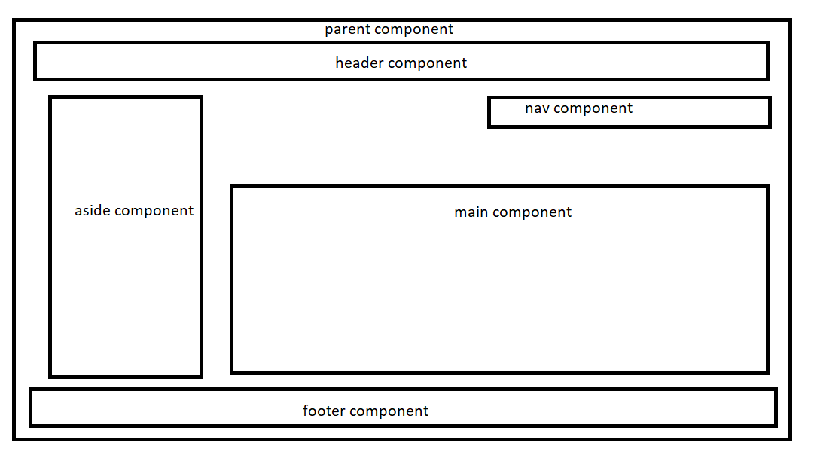

Node js

node --version

Npm (node package manager) : this tool is use to download external node js modules.

npm --version

npm install -g create-react-app

or

npx create-react-app demo-app

create-react-app –version

create-react-app demo-app

demo-app is project name

cd demo-app

npm start this command is to start the project

by default react js project run on port number 3000. It automatically open on default

browser with url as <http://localhost:3000>

In React every component must be return JSX (JavaScript and XML).

function add(a,b) {

console.log(a+” ”+b);

}

add(10,20);

add(“A”,”B”);

add(100);

add();

create-react-app --version

create-react-app welcome-app

JSX : JavaScript and XML

<html>

<head>

</head>

<body>

<h1>Welcome to HTML Page</h1>

<script type=”text/JavaScript”>

document.write(“<h1>Welcome to JavaScript</h1>”);

</script>

<h1>Welcome to HTML Page</h1>

<body>

</html>

function display() {

return “Welcome”;

return name;

}

In React JS every function ie component return JSX : JavaScript and XML.

React JS internally use babel transpiler which help to convert JSX to Plain JavaScript code.

Types of Components

In React We can create 2 types of component we can create

1. Function style component
2. Class style component

Stateful component

State less component

Before react hook. Function style component is known as stateless component. Class style component is known as state full component.

With help of react hook we can create state full component using function style also.

In React every component (function style with hook and class) contains two type of variables.

1. State : state variable is use to describe the component behaviour. State variable is known a mutable variable. Means we can change the value of state variable using functions.
2. Props : props is a type of variable which help to pass the value from one component to another component. Like a sharing the data between two component base upon their relationship. Props are known as immutable data we can’t change the value.

State variable is known as local variable. With help of props we can share the state data of one component to another components.

create-react-app react-component-types

cd react-component-types

npm start

customer -🡪 class style

product -🡪 function style

Day 3 :

09/08/203

* Functional vs class Components
* Props and state
* Conditional rendering
* Lists and keys

In Function component if we are planning to declare state variable then we need to use

useState() hook functions.

Hook concept doesn’t support by class component

Function component doesn’t support life cycle as well as constructor concept.

In class component we can change the value of state variable using setState() function with help of events.

useState syntax

let [variablename,functionName]=useState(intialValue);

we declare primitive, array and object reference type state variable in function components.

array of object type state variables and display in table format.

React forms

create-react-app react-forms

product management system

store product

display product

delete product

update product

**Day 4 :**

**10/08/2023**

* Component Lifecycle
* React Events
* React Forms
* Different Form Concepts
* Styling in React
* Inline Styling

create-react-app product-management-system

store product

display product

delete product

update product

CSS

1. Inline CSS with normal html page

<p style=”color:red;background-color:yellow;font-size:24pt”></p>

Inline CSS with React JS with JSX.

<div class=”DivTagClass”>

</div>

<div>

<p style={{“color”:”red”,”fontSize”:”20pt”}}></p>

</div>

If css property contains more than one word then those property name must be follow camel naming rules.

Means first word in lower case and 2nd word onward each word first letter upper case.

<div className=”divTagClass”>

</div>

Bootstrap is third party CSS open source framework which provided lot of pre defined css classes base upon DOM elements.

Calling Web Service in React JS

Web Service : Giving the service for web application when two application running using different technologies.

http java

Client SBI XML/JSON Hdfc

http Java Python/Asp.net

python/asp.net

two types

1. SOAP web service : in SOAP web service we can consume and produce the data only in the form xml.
2. Rest full web service : in rest full web service we can consume and produce data in any format base upon client requirement. Xml, json, plain text, html etc.

Amazon payment

Google pay

Phone pay

fetch() is pre defined function provided by Plain JavaScript which help to consume rest full web service develop in any language.

axios : it is a third party library provided by node js which help to call rest api. Axios internally use fetch concept.

Fetch and axios return type is promise.

Promise is a pre defined object provided by javascript which help to handle asynchronous event of data.

("https://dummyjson.com/products").  
then(result=>result.json()).  
then(result=>console.log(result.products)).catch(error=>console.log(error));

create-react-app react-rest-api

node js provided pre defined module ie

json-server which help to make normal static json file as a server.

npm install -g json-server

json-server myproduct.json

by default this file provide url with default port number

3000

<http://localhost:3000>

axios

routing

component communication : parent to child and child to parent

context api

redux

JWT Token : Json web token

JWT can be generate by java, python, cloud or third party library

Ui developer

Day 5 :

11/08/2023

* Routing
* React-router
* Features of React-router
* Configuration of routing using React-router
* Navigation using Links
* URL Parameters
* Nested Routes
* Build a REST API using JSON-server
* API consumption in React application using Fetch method

npm install -g json-server pre defined module provided by node which help to make normal json file as rest api or sample server which produce data in json format.

Please open the command in that location where *.json file stored

json-server filename.json

by default json server run on default port number 3000

react js use axios third party module which help to call rest api.

This module by default not a part of react project we need to install it.

Inside a project folder we need to install using command as

npm install axios

axios.get(“url”) get the data

axios.post(“url”,jsonobject) store the data

axios.put(“url”,jsonobject) update the data

axios.delete(“url”); delete the data

useEffect is a type of hook which help to call once component get loaded. Which is also known as side effect hook.

useEffect(callback,[state,props])

useEffect(callback,[depdencies])

useEffect(callback);

it will call once when component get loaded.

Then when we do render then it will call continuously again and again.

useEffect(callback,[state,props]);

it will call once when component get loaded and it will call only if any changes happen on state or props variable and that is only once.

useEffect is equal to life cycle of class component : componentDidMount(), componentDidUpdate and componentWillUnmount()

mount ----🡪 Render ---🡪 Unmount

before render after render

view on browser

React routing :

React and angular is use to create SPA. Single page application.

Using React router dom we can load only part of the web page or component JSX code base upon path provided in routing.

Router router dom is external module which we need to install after react js project created.

npm install react-router-dom

create-react-app react-routing-app

cd react-routing-app

npm install react-router-dom

BrowserRouter

MemoryRouter

We need to wrap BrowserRouter and MemroyRouter Tag with App component

To enable routing features for React application.

BrowserRouter keep the browser history details.

Html 5 semantic elements.

Before html5 we are developing layout of web page using div tag

<body>

<div id=”header”>

</div>

<div id=”nav”>

</div>

<div id=”main”>

</div>

<div id=”footer”>

</div>

</body>

<body>

<header>

</header>

<nav>

</nav>

<section>

</section>

<main>

</main>

<footer>

</footer>

</body>

Component communication

When we create any state variable inside a component ie functional or class component those variable are local to that components. If we want to share the data between one component to another component we can use

1. Using props

We need to understand relationship between two component

1. Parent to child -🡪 using props we can pass the value to parent to child.
2. Child to parent -🡪 using props with callback concept we can pass the value child to parent.
3. Child1 to child2 (sibling ): child1 pass the value to parent using props with callback and parent will pass the value to child2 using props.

<div>

<p></p>

<span></span>

</div>

For div, p and span are children

P and span are known as sibling.

<Parent>

<Child1></Child1>

<Child2></Child2>

</Parent>

Parent to child1 using props

Child1 to parent using props with callback

Child1 to child2 : child pass the value to parent using callback with props and parent pass the value to child2 using props.

Parent using props

Child1 Child2 Child3

Child4 Chlild5 Child6

Child7 Child8

Context API : using context API we can pass the value at any level for that components.